Tagebuch Flimmerpause

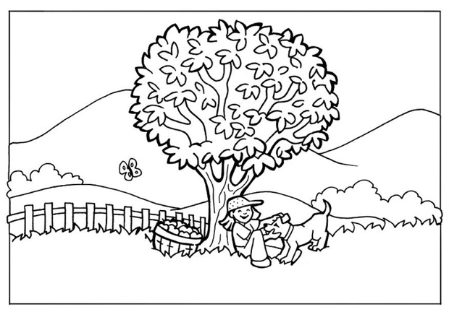

VON:

__________________________

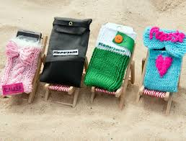

Ideenbox

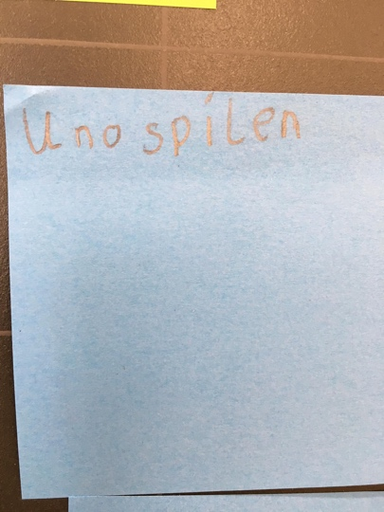

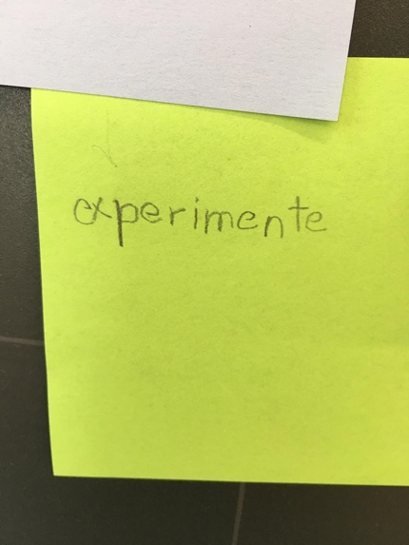

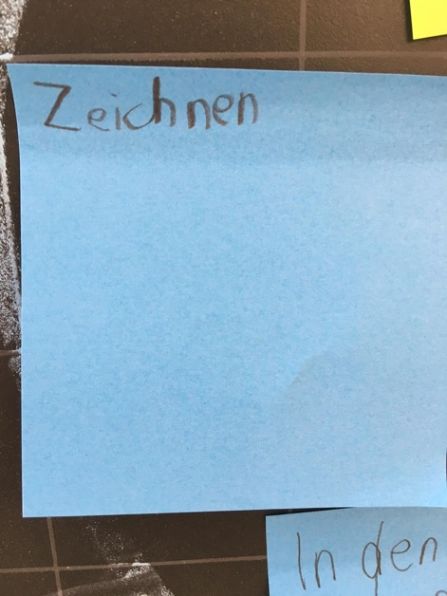

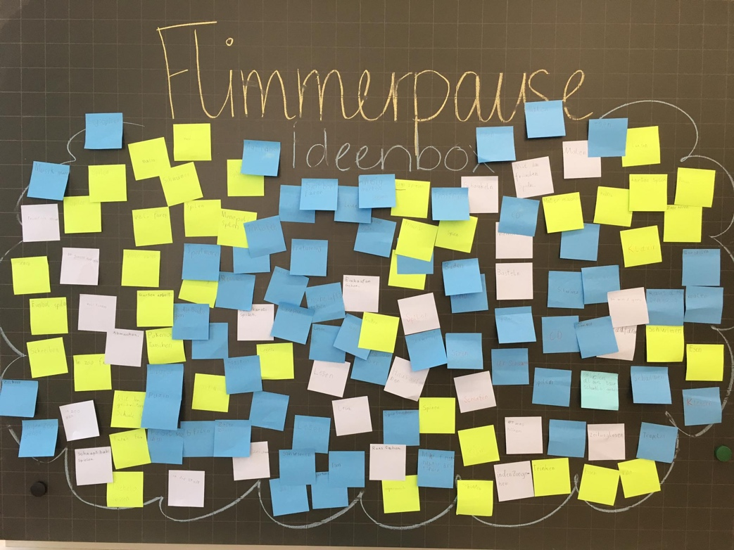

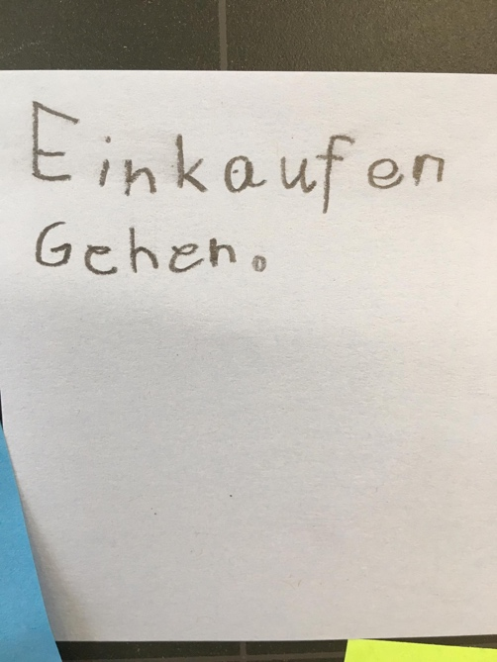

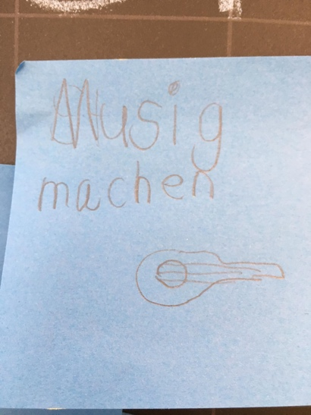

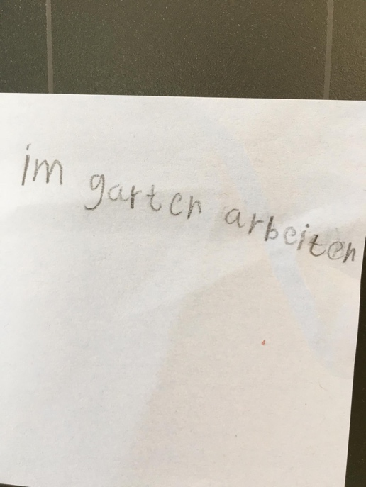

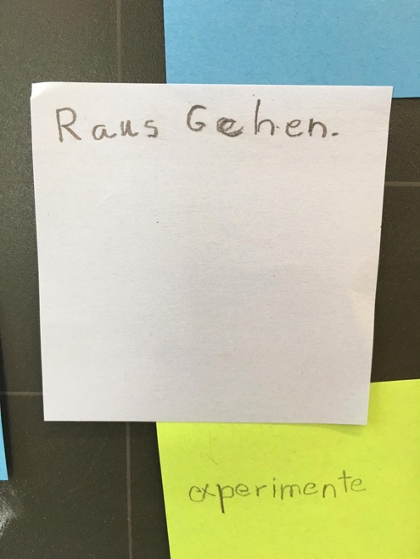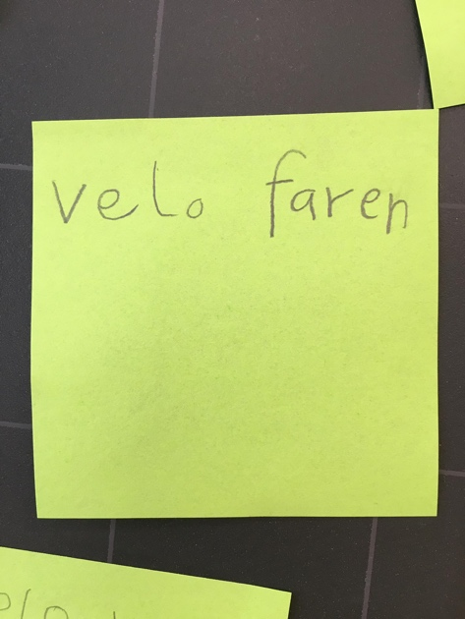

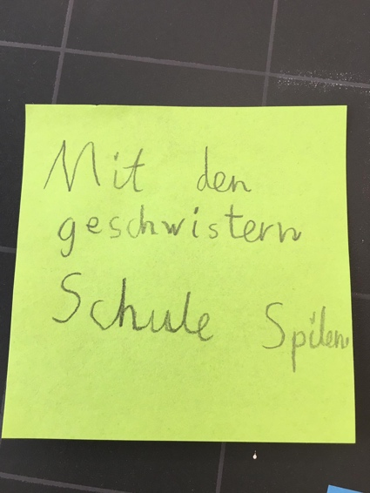

**Vertrag FLIMMERPAUSE**

Wir, die Klasse von Name LP, machen vom … bis …. eine Flimmerpause.

Wir vereinbaren, in dieser Zeit während der Freizeit…

…auf sämtliche Bildschirmmedien zu verzichten, Dazu gehören TV, Computer, Smartphone, Tablet ect…

…also auch keine Games zu spielen und kein Internet zu nutzen.

…den flimmerfreien Tagesablauf halten wir in diesem Büchlein fest.

Ich bestätige, dass ich bei dem Experiment Flimmerpause mitmache.

Ort: ________________ Datum: _______________

Unterschrift: ________________



**am Morgen**

**Dienstag, Datum**

_____________________________________________________

_____________________________________________________

_____________________________________________________

_____________________________________________________

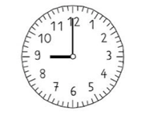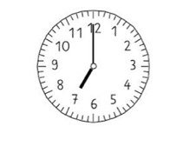



**am Vormittag**

_____________________________________________________

_____________________________________________________

_____________________________________________________

_____________________________________________________

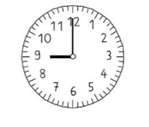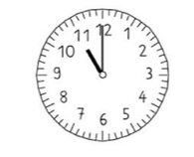

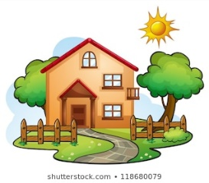

_____________________________________________________

_____________________________________________________

_____________________________________________________

_____________________________________________________

**am Mittag**

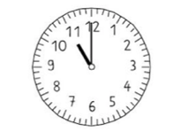

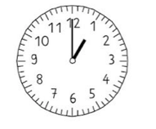



**am Nachmittag**

_____________________________________________________

_____________________________________________________

_____________________________________________________

_____________________________________________________

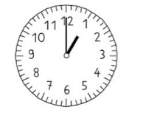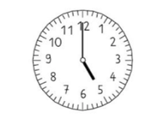



_____________________________________________________

_____________________________________________________

_____________________________________________________

_____________________________________________________

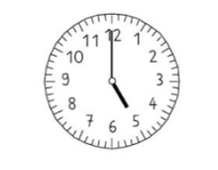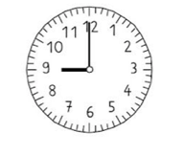

**am Abend**



**am Morgen**

**Mittwoch, Datum**

_____________________________________________________

_____________________________________________________

_____________________________________________________

_____________________________________________________





**am Vormittag**

_____________________________________________________

_____________________________________________________

_____________________________________________________

_____________________________________________________





_____________________________________________________

_____________________________________________________

_____________________________________________________

_____________________________________________________

**am Mittag**







**am Nachmittag**

_____________________________________________________

_____________________________________________________

_____________________________________________________

_____________________________________________________





_____________________________________________________

_____________________________________________________

_____________________________________________________

_____________________________________________________



**am Abend**



**am Morgen**

**Donnerstag, Datum**

_____________________________________________________

_____________________________________________________

_____________________________________________________

_____________________________________________________





**am Vormittag**

_____________________________________________________

_____________________________________________________

_____________________________________________________

_____________________________________________________





_____________________________________________________

_____________________________________________________

_____________________________________________________

_____________________________________________________

**am Mittag**







**am Nachmittag**

_____________________________________________________

_____________________________________________________

_____________________________________________________

_____________________________________________________





_____________________________________________________

_____________________________________________________

_____________________________________________________

_____________________________________________________



**am Abend**



**am Morgen**

**Freitag, Datum**

_____________________________________________________

_____________________________________________________

_____________________________________________________

_____________________________________________________





**am Vormittag**

_____________________________________________________

_____________________________________________________

_____________________________________________________

_____________________________________________________





_____________________________________________________

_____________________________________________________

_____________________________________________________

_____________________________________________________

**am Mittag**







**am Nachmittag**

_____________________________________________________

_____________________________________________________

_____________________________________________________

_____________________________________________________





_____________________________________________________

_____________________________________________________

_____________________________________________________

_____________________________________________________



**am Abend**



**am Morgen**

**Samstag, Datum**

_____________________________________________________

_____________________________________________________

_____________________________________________________

_____________________________________________________





**am Vormittag**

_____________________________________________________

_____________________________________________________

_____________________________________________________

_____________________________________________________





_____________________________________________________

_____________________________________________________

_____________________________________________________

_____________________________________________________

**am Mittag**







**am Nachmittag**

_____________________________________________________

_____________________________________________________

_____________________________________________________

_____________________________________________________





_____________________________________________________

_____________________________________________________

_____________________________________________________

_____________________________________________________



**am Abend**



**am Morgen**

**Sonntag Datum**

_____________________________________________________

_____________________________________________________

_____________________________________________________

_____________________________________________________





**am Vormittag**

_____________________________________________________

_____________________________________________________

_____________________________________________________

_____________________________________________________





_____________________________________________________

_____________________________________________________

_____________________________________________________

_____________________________________________________

**am Mittag**







**am Nachmittag**

_____________________________________________________

_____________________________________________________

_____________________________________________________

_____________________________________________________





_____________________________________________________

_____________________________________________________

_____________________________________________________

_____________________________________________________



**am Abend**